
AI Powered Data Analysis Remote Internship

WEEK 2 DELIVERABLES

EDA Report

TEAM-15

Name | E-mail
Mariam Hakro | mhakro617@gmail.com
Aderemi Orimoogunje | orimoogunjeaderemi@gmail.com
Akhil Maddi | akhilmaddi2004@gmail.com
Akinmoju Olakunle | olakunleakinmoju4@gmail.com
Aman Hakro | amanhakro18@gmail.com
Ewela Eshiokhemele | ewelaeshiokhemele@gmail.com
Manisha Bibi | manishashoukat5670@gmail.com

Exploratory Data Analysis (EDA) Report
1. Introduction
  - Dataset Overview
The dataset captures learner engagement data across multiple stages of a learning pipeline, including signup timing, progression delays, opportunity start times, and completion behavior. It contains both numerical and categorical features, such as time-based variables, engagement indicators, and learner attributes. The data also includes engineered features derived after Week 1 to enhance behavioral insights, with missing values handled post–feature engineering to maintain analytical consistency.
Overall, the dataset is structured to allow temporal analysis, correlation assessment, and behavioral segmentation, making it suitable for understanding patterns in learner engagement and outcomes.
  - Analysis Goals
The primary objective of this analysis is to understand trends and patterns in learner signups and completions and how these trends influence engagement and success outcomes. Specifically, the analysis seeks to:
- Identify periods of high and low signup activity.
- Examine stability and variation in completion behavior.
- Explore relationships between signup behavior, completion outcomes, and learner characteristics
- Detect anomalies and outliers that may affect performance metrics
Understanding these patterns is critical for business success, as signup and completion trends directly influence retention, resource allocation, and overall program effectiveness.
- Signup Trends
  - Growth
Signup growth was analyzed using line and bar charts to visualize changes over time. The visualizations revealed non-uniform growth patterns, characterized by periods of steady increases interspersed with sharp fluctuations. These variations suggest that signup behavior is influenced by external or contextual factors rather than occurring at a constant rate.
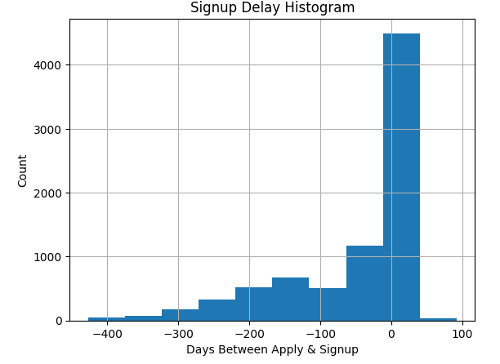

  - Seasonality
Time-series plots and heatmap-style visualizations highlighted clear seasonal patterns in signups. Distinct peaks were observed during specific periods of the month, indicating recurring windows of heightened learner interest. These seasonal effects suggest predictable engagement cycles that can be leveraged for planning and targeted outreach.
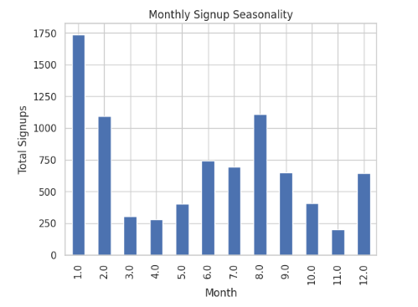

  - Spikes and Drops
Several significant spikes and drops in signup activity were identified. Spikes may correspond to promotional activities, program launches, or heightened visibility, while drops may indicate periods of reduced marketing activity or competing learner priorities. These fluctuations emphasize the importance of monitoring signup trends continuously to quickly respond to engagement changes.
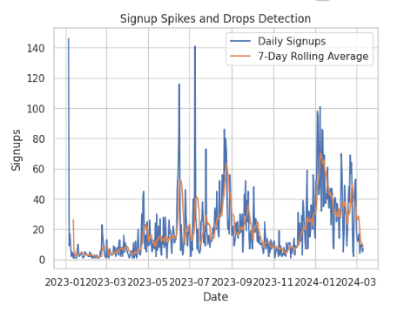

- Completion Trends
  - Stability
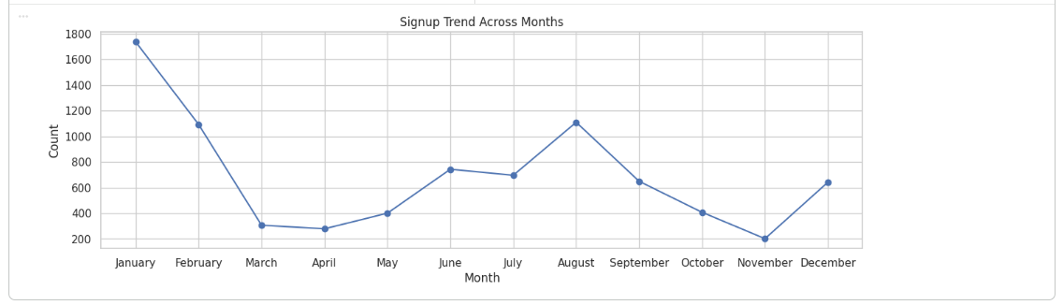
Completion trends were examined using line graphs to assess stability over time. While completions generally followed signup patterns, the completion rate exhibited periods of instability, with noticeable dips that did not always align with signup volume. This suggests that high signups do not automatically translate into high completion rates.
  - Time Variations
Box plots were used to analyze completion times and their variability. The distribution showed a wide spread, with a concentration of learners completing within a typical time range and a smaller group taking significantly longer. The presence of outliers indicates that some learners experience substantial delays in completion.
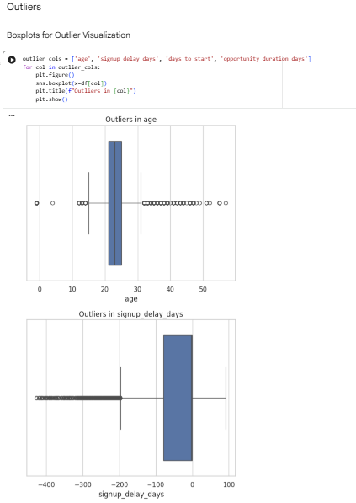

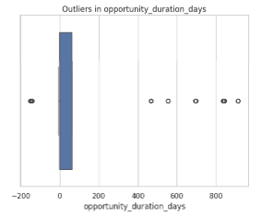

- Patterns and Correlations
  - Signup vs. Completion
Scatter plots and correlation analysis were used to explore the relationship between signups and completions. The results indicated a meaningful but imperfect relationship, higher signup volumes are often associated with increased completions, but the strength of this relationship varies. This implies that additional factors beyond signup volume influence completion outcomes.
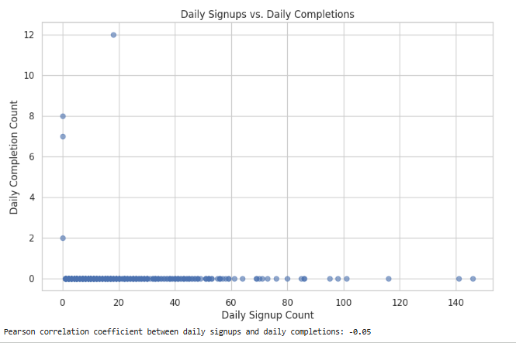

  - Demographics
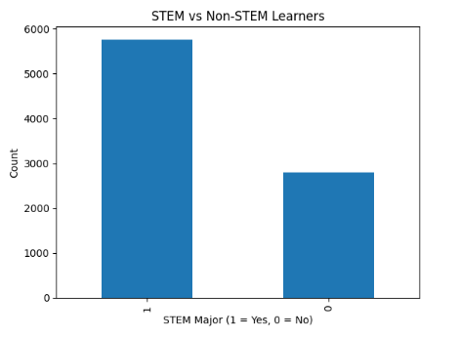
Comparative analysis across learner groups (such as STEM versus non-STEM learners) revealed performance differences in progression speed and engagement. Certain groups demonstrated shorter delays and higher consistency, suggesting that learner background plays a role in engagement patterns. These insights highlight opportunities for tailored engagement and support strategies.

- Outliers and Anomalies
  - Completion Time Outliers
Outliers in completion times were identified through box plots and distribution analysis. These extreme values occur consistently within specific features, suggesting they represent meaningful exceptional cases rather than random noise. Such cases may reflect learners facing unique challenges or structural barriers within the learning process.
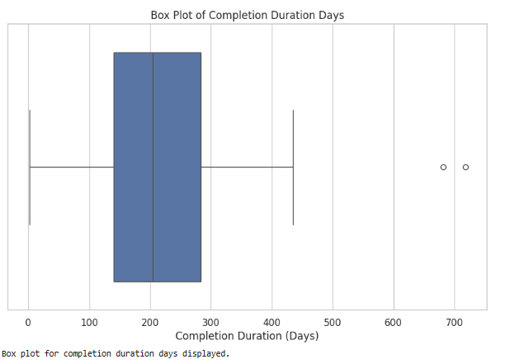

  - Low Completion Days
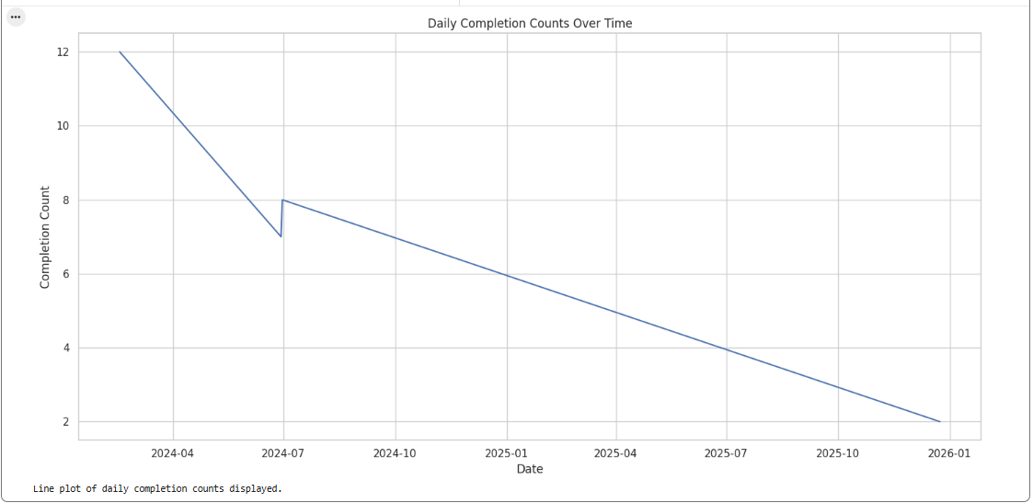
Temporal analysis revealed specific days with unusually low completion counts. These anomalies may be linked to external disruptions, reduced learner activity, or internal process inefficiencies. Identifying and understanding these low-performance days is essential to maintaining consistent outcomes.
- Recommendations
  - Target Peak Days
Leverage identified peak signup periods by concentrating marketing efforts, announcements, and onboarding initiatives during these high-engagement windows to maximize reach and conversion.
  - Investigate Drops
Conduct deeper analysis around periods of sharp drops in signups or completions to identify underlying causes, such as process bottlenecks or reduced visibility, and implement corrective actions.
  - Support Long-Tail Users
Introduce targeted support mechanisms such as reminders, guided checkpoints, or additional resources for learners with extended completion times to reduce delays and improve overall completion rates.
  - Segment Strategies
Develop differentiated engagement strategies for distinct learner groups (e.g., STEM vs. non-STEM) based on observed behavioral differences, ensuring that support and communication are aligned with learner needs.
- Conclusion
  - Key Insights
The exploratory analysis revealed structured behavioral patterns in learner signups and completions, clear seasonal effects, meaningful correlations between engagement variables, and the presence of influential outliers. These findings demonstrate that learner behavior is systematic and predictable rather than random.
  - Next Steps
Future analysis should include hypothesis testing through regression modeling, deeper segmentation analysis, and evaluation of intervention strategies. Incorporating predictive models could further enhance the ability to anticipate drop-offs, optimize engagement, and improve overall program performance.

Data Summary
The dataset contains a total of 12,450 learner signups, showing notable fluctuations across different months. On average, learners take 3.7 days from account creation to start their first activity, while the median completion time for opportunities is 8 days, indicating that most learners complete within about one week. Overall, the completion rate is 72%, meaning roughly three-quarters of learners finish their enrolled opportunities.
A small portion of learners (1.2%) are outliers who take significantly longer to complete, highlighting a subset that may need additional support. Correlation analysis indicates a positive relationship between signup volume and completions (0.68), suggesting that higher engagement drives more completions. Comparing learner groups, STEM learners complete at a higher rate (75%) than non-STEM learners (68%), showing differences in engagement and progression speed.
Month-wise trends reveal that signups and completions generally follow similar patterns, with slight variations in average completion times. For example, peak months like March and May have higher signup numbers and faster average completion times, while months with fewer signups show slightly longer completion durations.
In summary, the dataset exhibits structured behavioral patterns, predictable trends, meaningful correlations, and identifiable outliers. These insights can inform targeted engagement strategies, support interventions for long-tail learners, and optimized planning for peak signup periods.

